Galileo & Hypatia
27 October 2008

Chapter 1: IYA Trailer

 | Thumbnail/Scene | Text
 | Hypatia enters a row of seats and makes her way to the center of the row while stepping on the toes of the other patrons. | Ouch! Sorry. Scooz me My toes! Sorry
 | Cell phone rings. | Hey, could you turn that thing off?
IYA trailer
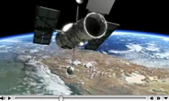
 | LTBN trailer ends.

Chapter 2: Galileo’s Discoveries

 | Hypatia stands and makes her way out of the theater. She is greeted with the bright lights of the city and starts her walk. | Hypatia: This sure doesn’t look anything like the beautiful night sky I saw in the movies. These darn city lights are ruining my view. I know we need some for our safety, but do we really need this many? Gosh, dim it all!
 |  | Why do the lights have to shine on clouds, airplanes, and the bellies of birds? Why not just down to the ground where they are needed? What a waste of energy, light, and money! Light pollution didn’t exist hundreds of years ago. I bet they had a perfect sky. Hey, I have an idea….
 | At the entrance of Great Hall. Starts walking down to Hologrid. | Let’s go back in time and… Let There Be Night! To travel back in time, we’re going to visit a time transporter. It’s here that we’ll teleport to one of the first persons to use a telescope for science--Galileo Galilei. Imagine, visiting with one of the all time greats in Astronomy.
 | At INFO console. | Heeeere we go.
 | Hypatia teleports to Galileo’s villa with a sign next to the door that identifies it as “The Jewel of Galileo.”
 | She flies over the wall of the villa into courtyard. | Hypatia: Boy it’s dark in here.
 | Glare of candle in her eyes. | I have light, but I still can’t see very well.
 |  | Maybe if I block the candle flame with my hand I’ll be able to see. Now that’s much better.
 |  | Ooooh, nice telescope.
 | From balcony. | Galileo: What’s going on down there? Who is that?
 |  | Hypatia: Hi Galileo. My name is Hypatia. I was trying to come in quietly, and well… Sorry for waking you.
 |  | Galileo: Ahhh a visitor.
 | Descending from balcony. | Hypatia…she was an astronomer in ancient Greece.
 |  | Hypatia: That’s right. I was named after her.
 | In courtyard of villa. | Galileo What? A talking mouse? I must be dreaming!
 |  | Hypatia: The sign outside your house suggests it’s the Jewel, but it seems more like a jail.
 |  | Galileo: I am confined here under house arrest, which means I’m a prisoner in my own home.
 |  | Hypatia: Why?
 |  | Galileo: After a few key discoveries with my telescope, I interpreted the evidence. Apparently my ideas have put me in conflict with the Church and, well, this is the mess I’m in.
 |  | Hypatia: What discoveries are you talking about?
 |  | Galileo: I can show you if the sky is clear.
 |  | Hypatia: It is beautiful. However, when I was in the city earlier tonight I could only see a few stars because of light pollution?
 |  | Galileo: What’s light pollution?
 |  | Hypatia: Let’s just say the sky looks pretty above your courtyard.
 |  | Galileo: Then let’s use my telescope to look at a few things. Light pollution…I wonder what that is…
 |  | Hypatia: Didn’t you invent the telescope? After all, you did brag about it in your book Starry Messenger.
 |  | Galileo: (Belly laugh) Aahhh, I have to confess, I didn’t really invent the telescope. A Dutch lens maker named Hans Lippershey and others actually came up with the idea and tried to patent it. I heard about his idea and then crafted a few telescopes of my own. Made them by hand. My working scope is simply bound in paper, nothing fancy.
 | 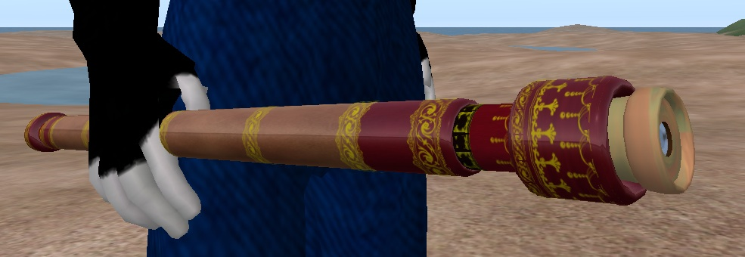 | My new improved telescope here is leather bound with gold inlay—and that’s just the tube! While others are building telescopes with two or three times magnification, I'm making scopes that magnify the image thirty times!
 | SL dance. | Mine are simply the best.
 |  | Hypatia: Didn’t you discover a lot of cool things with your telescope?
 |  | Galileo: I’m not sure what you mean by cool. But I used my scope to make some discoveries that are changing our view of the heavens, and the Earth’s place in it. Until now many people thought the Earth was the center of everything, and with this new tool, I and others could see that’s not the case.
 |  | As an example, over many nights I looked at Jupiter through my scope and this is what I saw.
 | Series of Galilean moon drawings from Starry Messenger. | As you can see there are four objects going around Jupiter. If Jupiter is the center of those four things…then Earth is no longer the center of all! With this new evidence, the old model clearly no longer works.
 |  | Hypatia: Anyway, your conclusion was amazing, considering the view through your scope is so tiny.
 |  | Galileo: I can see things just fine!
 |  | Hypatia: Today we call those four “things” moons.
 |  | Galileo: Whoa, wait a second. What do you mean “today?” Today IS today!
 |  | Hypatia: Now don’t get upset. I’ll explain what I mean about “today” a little later.
 |  | Galileo: Earlier she mentioned “light pollution,” and now “today” isn’t really today. She’s a strange little mouse.
 |  | Hypatia: Today, the moons of Jupiter you saw are referred to as the Galilean Moons…named after you!
Galileo. I’m honored!
Hypatia: Would you to like to see Jupiter and its moons through my telescope?
 |  | Galileo: Ooooookay….where’s your telescope?
 | It materializes right in front of them and next to Galileo’s telescope. | Hypatia: It’s right here.
 |  | Galileo: Oh, my! I can’t take much more of this weird stuff!
 |  | Hypatia: Here, take a look.
 | Modern telescopic view. | Galileo: That’s spectacular! I can’t believe that image looks so magnified.
 |  | Hypatia: Oh Galileo, even that view is small compared to our most powerful 21st century telescopes.
 | SL-Galileo jaw drop | Galileo: The 21st century? That’s 400 years from now. How can that be?
 |  | Hypatia: Why don’t you show me your other discoveries, and then we’ll compare views.
 | Image of defocused moon. | Galileo: For centuries, since Aristotle, many people thought the Moon was a smooth crystalline sphere.
 | Galileo’s drawings of moon. | However when I examined the Moon with my telescope…I realized it was made up of rugged mountains, and deep valleys. Take a look at some of my drawings
 |  | Now, let’s see what it looks like through your scope.
 | Modern telescopic view of moon. | Whew! Incredible!
 | Galileo diagram from Starry Messenger. | Did you know, using lunar shadows and simple trigonometry, I was able to calculate the heights of those mountains?
 | Galileo’s drawing segues to silhouette of Hypatia’s head with ears. | When I observed Saturn it looked like it had ears!
 |  | Hypatia: Later on as we improved the telescope we could see that those “ears” were actually rings.
 |  | Galileo: Rings, did you say rings?
 |  | Galileo: What makes up the rings? How did they form? Can you stand on them? Do they move?
 | Saturn images. | Hypatia: The rings might represent a Moon graveyard, where in the past a few icy moons may have collided with each other;
 |  | or, they were simply moons torn apart by the gravity of Saturn. Either way, in their wake are a few thousand rings of ice and sand-sized particles of rock.
 |  | No, you can’t stand on them because they are not solid, and yes, they revolve around Saturn.
 | Galilean drawing of Venus phases juxtaposed with his drawings of moon phases. | Galileo: Did you know I observed Venus through my telescope for over two and a half years? I was amazed to discover that it went through the same phases our moon goes through.
 | Animation of Venus phasing as it orbits the Sun. | Galileo: Are you noticing our Moon phases are pretty much the same size, and the phases of Venus vary in size? Now if we put my pictures into motion around the Sun, you might be able to see how I came up with the idea that Venus was orbiting the Sun and not the Earth as most people believed.
 |  | Hypatia: I get it now. Moon phases stay the same size because our moon remains pretty much the same distance from us as it goes around the Earth. The phases of Venus vary in size because the distance between Earth and Venus changes as they orbit the Sun.
 | Galileo and Hypatia in front of sun. | Galileo: I also was one of the first people to study Sunspots. They are small areas on the sun that appear to be black. They also move, indicating the time of the Sun’s rotation.
 |  | Hypatia: There’s one thing I need to mention about the Sun.
 | Hypatia turns to the audience—zoom into upper face. | I don’t want any of you to EVER look directly at the Sun, especially with a telescope. It’s way too dangerous. If you do, the Sun might be the last thing you ever observe. So please, don’t ever look directly at the Sun…okay?
 | Hypatia turns to Galileo | With your telescope you made some great discoveries, and because of that, we consider you a giant in the world of astronomy.
 | SL- Galileo muscle flex. | Galileo: A giant huh…I like that! Woohoo!
 |  | Hey, look over here at this ribbon of faint light arching across the sky. Do you know what that hazy band of light is?
 |  | Hypatia: Sure! It’s the Milky Way. Though I’ve never seen it like that. Where I live we can barely see it because of…
 |  | Galileo: I know-- light pollution.
 |  | Are people placed under house arrest for light pollution?
 |  | Hypatia: No, but often they confine themselves and their telescopes to the indoors at night.
 |  | Galileo: How sad, for to see the truth, one ought to look through a telescope, not store it in a closet. They’d see the Milky Way is made up of hundreds of stars.
 | Hubble image of stars. | Hypatia: Actually we’re looking at millions of stars and they all belong to our galaxy. Here take a look.
 |  | Galileo: Want to see one more thing?
 |  | Hypatia: Sure.
 |  | Galileo: The Greeks called this constellation Orion the Hunter.
 | Dayle Brown illustrations of Orion | Hypatia: Other cultures saw a giant…or three zebras…or three brave hunters pursuing a polar bear.
 | Galileo drawing of Orion Nebula from Starry Messenger. | Galileo: With my telescope, I observed this part, below the three belt stars.
 |  | I’ll bet if we aim your telescope at this area we’ll see some interesting things.
 |  | Galileo: What is that thing?
 | Orion Nebula image | Hypatia: We call it the Orion Nebula. It’s a star nursery where stars form.
 |  | Galileo: Right there, we’re seeing the birth of stars! Amazing...truly amazing.
 |  | Hypatia: Galileo, you forgot to mention that you discovered planet Earth.
 | Hypatia riding Earth | Hypatia: Think about it. Before you made your discoveries, the Earth was….well, just the Earth and everything went around it. Because of you, we now know the Earth—a planet—goes around the Sun, just like Venus, Jupiter and all the others.
 |  | Galileo: Well I can’t take all the credit, many people had a lot to do with that, but I guess I did help contribute to that notion and that is really….cool!

Chapter 3: Light Pollution Issues

 | Hypatia and Galileo in villa courtyard | Hypatia: You sure do have beautiful sky, much prettier than my sky back home.
 |  | Galileo: The stars here are the same ones you should be able to see.
 |  | Hypatia: Yes I know. The star patterns are the same as yours, but we just can’t see all of them. In many places we can’t even see the Milky Way.
 |  | Galileo: What’s the cause for your light pollution?
 |  | Hypatia: Lights! Lots, and lots of outdoor lights.
 |  | Galileo: Why do you have all of those lights?
 |  | Hypatia: We need sufficient lighting in our modern society. We use lights at night for: (Pictures of bad lights) security around our buildings and homes; (Picture) shopping mall parking lots; (Picture) advertising bill boards, (Picture) streets, and decoration to name a few.
 |  | Hypatia: The problem is, most of the lights go up, down, out, and every direction in between—well beyond the intended target. It’s so bad we divide light pollution into three categories:
 | Diagrams | Glare, where the light shines directly into your eyes;
 |  | Light Trespass, where light spills over onto your neighbor’s property;
 |  | and Sky Glow, which washes out the night sky.
 |  | Galileo: I’m beginning to see the problem.

Chapter 4: Why Should I Care/What’s at Risk?

Time | Hypatia and Galileo in villa courtyard | Galileo: Hypatia, if you could come here to my century, can we go to your time and place?
 |  | Hypatia: Sure.
 |  | Galileo: Then let’s bust out of this prison. It’s jailbreak time.
 | Hypatia and Galileo fly through Florence with streetlights and on to Hypatia’s city | Hypatia: Okay, heeere we go.
 |  | Galileo: Ouch these lights hurt my old eyes. Gosh, dim it all. Where are we?
 |  | Hypatia: This is “today” for me…and for you, it’s the future
 | Galileo puts his hand up in front of his eyes to shield them from the glare | Hypatia: Do you see what you’re doing? It’s intuitive to put your hands up to shield your eyes from the bright lights.
 | Animation: Light with arrows terminating at dollar signs; shield reflects downward | By shielding the light—without lessening the amount of light that reaches the ground, we can also reduce the energy to this fixture;
 |  | eliminate unwanted light;
 | Eliminate reflected wavy arrows so you’re left with original light levels | and save taxpayer money.
 |  | Galileo: You still pay taxes?
 |  | Hypatia: By reducing energy we can also cut down on green house gases that contribute to global warming.
 |  | Galileo: You have a global warming problem, too?
 |  | Hypatia: Current evidence seems to indicate that.
 |  | Galileo: I was going to ask if you people use the night sky--you know, like for story telling, or for determining time and the seasons. Now I know the answer. You don’t! You can’t!
 |  | So why should anyone care about outdoor lighting issues?
 |  | Hypatia: It’s not just about astronomy.
 | Drawing | Glare overwhelms our eyes, creates shadows, and reduces personal security—which is often why people claim they need lights in the first place.
 |  | More lights certainly don’t mean better security—they usually just means more glare.
 | Drawing | In the bright lights, many times a motorist can’t see a pedestrian, cyclist, or safety signs located along the sides of roads?
 |  | Galileo: I’m not sure what you mean—motorist—but go on.
 |  | Hypatia: In addition to what we’ve mentioned…
 | Drawing | energy and money; personal security; motorist safety; we now know that light pollution is an emerging environmental concern, too.
 | Owl swoops down by Hypatia. | Galileo: Hypatia, look out!
 |  | Hypatia: Phew, that was scary. See the problem nocturnal animals like me have? Light pollution affects the whole predator-prey relationship. I lose my protection with all these lights. And I can’t forage for food easily.
 | Drawing | Tall buildings and lighted towers confuse migrating birds. The circling birds either die of exhaustion or die of collisions—with each other or with the structures themselves.
 | Drawing | When sea turtles hatch on the beach, they find the ocean by moving away from the dark silhouette of dunes and vegetation. When artificial lights interfere, the turtles are attracted inland instead of seaward.
 | Drawing | Studies suggest that light pollution impacts salamanders, bats, moths, owls, fireflies--even algae and zooplankton—the list goes on.
 |  | So you see, Galileo, everything —even human beings—are taking a beating. The balance of nature is at risk.

CHAPTER 5: SOLUTIONS
 | Moths circling a light; some getting zapped when they fly too close. | Galileo: You modern people are so enamored with lights–you’re like circling moths, getting singed by the technology.
 |  | Galileo: Sooo, , , how do you turn off these brilliant lighting devices? It must be extremely complicated and expensive.
 |  | Hypatia: Actually, it only takes a flick of a switch.
 |  | Galileo: A flick of a switch?
 | Alter urban lights with red switch. | Hypatia: Yep. We can simply turn off lights we’re not using with the flick of a switch.
 | Shielded lights replace poor lighting | Galileo Hey, you dimmed it, and I can still see well.
 | List items | Hypatia: Lots of simple ideas work: shield the lights;
 |  | direct all the light to where it belongs;
 |  | install motion detectors.
 | Lumens lessened on light bulb | If you switch your light bulbs to a lower wattage, take the time to lower the lumens, or brightness, as well.
 |  | Or simply turn the light off.
 |  | Galileo: If you make people aware of the issues, then maybe they will change their habits.
 |  | Hypatia: Correcting the impact of light pollution is often just a matter of awareness. Hey, with smarter lighting practices, we all win.

Chapter 6: Quantifying Light Pollution
 |  | Galileo: How do you modern people know when enough outdoor lighting is enough? How much of the night sky have you already lost?
 | Constellation outlines | Hypatia: We can measure sky brightness in several ways. For example, people around the world are going to count the stars of a particular constellation. Depending on one’s location and the season they might look at : Orion the Hunter, Cygnus the Swan, [error:] Scorpius the Scorpion [Sagittarius], or the Little Dipper in Ursa Minor
 |  | Galileo: And doing so will quantify your light pollution? How does that work?
 | 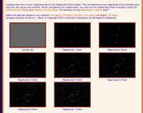 | Hypatia: During the star count people will compare what they see from home with several star charts like this. The more light pollution, the fewer stars.
 |  | Everyone will enter their information—location, weather, and chart number—into a computer, which will help compare all of the observations.
 |  | Galileo: I’m not sure what you mean by computer, but go on.
 | 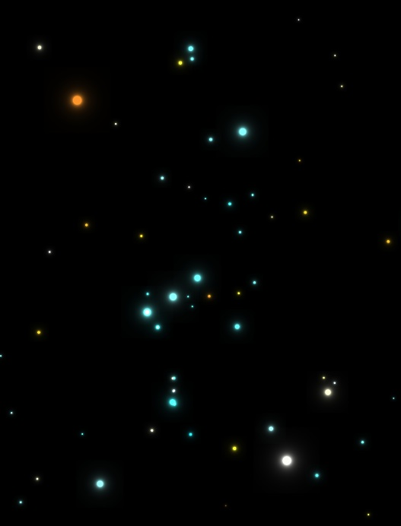 | Hypatia: Each picture of Orion is defined by the faintest stars that can be seen with the unaided eye. The magnitude numbers vary from picture to picture because of varying amounts of light pollution.
 | Magnitudes from 1 to 6 over Galileo’s head | Galileo: Magnitudes huh? Hipparchus created a magnitude scale centuries ago. The brightest stars were labeled magnitude +1, and the very faintest stars were magnitude +6.
 | Orion slider from Globe at Night. | Here in your sky, with lots of light pollution, your visibility is limited to a handful of magnitude 1 stars. If you had no sky glow, like in my time, you could see thousands of stars, all the way to magnitude 6--near the limit of the human eye. This is the view you’re being denied because of light pollution.
 | Sky Quality Meter | Hypatia: Some star counts will also use a hand held Sky Quality Meter, or SQM, which gives a digital display of the amount of sky glow overhead. This SQM scale is similar to the magnitude scale. The lower the number, the lower the quality of your night sky
 |  | If we went back to your night sky with this meter…the reading would probably be around 21, the perfect sky.
 |  | Galileo: So anything less than 21 indicates how much night sky you’ve already lost. At what point do you draw the line?

Chapter 7: The Future

 |  | Galileo: You brought me to my future. What is your future?
 | Teleport to a SL International Spaceflight Museum | Hypatia: Allow me to show you.
 |  | Gallileo: Where are we? What are those tall columns?
 |  | Hypatia: These are rockets that have taken us into the new frontier of outer space.
 | Fly up the Saturn V | Hypatia: This one took men to the Moon.
 |  | Galileo: Humans have actually landed on the Moon?
 |  | Galileo: I’ve always wanted to drop two things off a tall tower. Aristotle claimed the heavier object would hit the ground first. Can I try it here?
 | Galileo drops two objects, one bigger than the other. Both hit ground at same time. | Hypatia: Sure.
 |  | Hypatia: How about a feather and a hammer?
 |  | Galileo: If there is no atmosphere to slow the feather down…yes, I declare they would still hit at the same time.
 |  | Hypatia: Well have I got something to show you. Here’s Astronaut Dave Scott on the moon, which has no atmosphere.
 | Apollo 15 clip. Astronaut Dave Scott makes a reference to Mr. Galileo | Galileo: (whispers when his name is mentioned) “Hey, that’s me he’s talking about.”
 | Apollo 15 clip shows the feather and the hammer hitting the lunar surface at the same time. | Galileo: Phew, it worked.
 | Collage of planets | Hypatia: We’ve landed unmanned spacecraft on Venus, Mars, a comet, an asteroid and Titan, the big moon of Saturn. We have flown by every planet, and are on our way to Pluto, whatever it may be. I bet you didn’t know about the planets Uranus and Neptune.
 |  | Galileo: No, I didn’t.
 | Galileo illustration with Neptune to upper left. | Hypatia : Actually, you observed the planet Neptune—it’s in your drawings. But through your telescope it appeared to be another star.
 |  | Galileo: What’s that?
 | NASA animation of James Webb Telescope | Hypatia: That ‘s an orbiting telescope that allows us to see the Universe in infrared wavelengths.
Galileo: Infrared wavelengths?
Hypatia: It’s part of the electromagnetic spectrum.
Gallieo: The what?
Hypatia: The electromagnetic spectrum–it’s the range of light you can see and light that you can’t see.
Galileo: Light you can’t see… you’ve lost me.

 | Diagram of the spectrum | Hypatia: This spectrum is made up of all light energy. In the very center are the visible colors of a rainbow. Each color has a different wavelength. The longest wavelength is shown on the left and the shortest wavelength on the right.
 |  | Galileo: Hey, I see infrared on this chart.
 |  | Hypatia: That’s right. Infrared is invisible light energy whose wavelength is a little too long for our eyes to see. Next to that, we have a slightly longer wavelength called microwave, followed by radar. The longest wavelength is radio. On the other side of visible light are the shorter invisible wavelengths of ultraviolet, x-ray, and finally gamma ray.
 |  | Galileo: So, you’re saying the satellite telescope we just saw allows us to “see” what the sky looks like in infrared? I bet you have a telescope for every one of those invisible wavelengths.
 | Orion in infrared | Hypatia: Yes we do, and they make a big difference in how we observe the Universe. Here’s Orion in the infrared.
 |  | Galileo: That’s a beautiful picture, but where is Orion?
 | Starfield next to infrared with outlines | Hypatia: It right in front of you.
 |  | Galileo: (Gasping) I am so impressed.
 |  | Hypatia: Just as your telescope changed our vision, these modern instruments allow us to see the universe in a new light.

Chapter 8: CONCLUSION
 | Returning to SL INFO panel | Galileo: So where do you go from here, Hypatia?
 |  | Hypatia: As people become aware of the issues, they’ll hopefully turn down the lights.
 | Turning to the audience | It’s time to act, because we are all stewards of the night.
 |  | Galileo: Speaking of time…I think it’s time for me to go back home…back to my beautiful sky.
 |  | Hypatia: Meeting you Galileo was the thrill of my life.
 | Galileo teleports to outside the door to his house. | Galileo: The pleasure was mine, Hypatia. Thank you, and good luck.
 |  | Galileo: Remember, the balance between day and night is in your hands. Let there be night!
 | Starball song “Let There Be Night” excerpt; credits
 | Galileo at telescope; pulls out to sky over villa that segues into satellite view of Earth at night. | Galileo: I’m not afraid to get old. It’s just the thought of loosing touch that really scares me. And I’m never one to shy away from all the difficult questions. I’m a rational guy.
 | Bandazian song “Lucifer’s Bait.”

